Handwritten Card
Kit 1

This stunning greeting card is to be handwritten and attached to your Introduction Kit.

If applicable, add a personal note to the card about something from the initial conversation you had (i.e. interesting and relevant Client Profile information).

Dear [Prospective New Client],
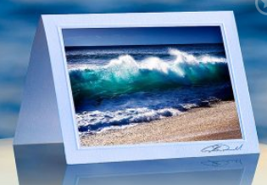
It was a pleasure speaking with you today.

As promised, here is our Introduction Kit to provide you with additional information about who we are what we do.

I look forward to meeting you.

Advisor’s Signature

