Your Personal Financial Organizer

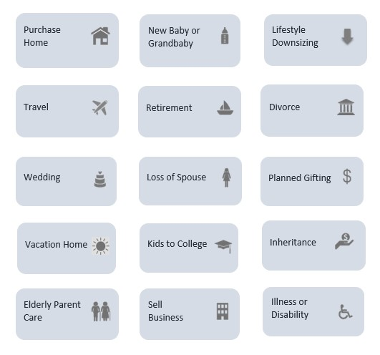

Helping You Manage Your Significant Life Events

Client Name: ________________
Date: __________

CASH FLOW PLANNING  Allowing you to focus on enjoying life day by day | Date Last Reviewed

TAX PLANNING  Helping you keep more of your money | Date Last Reviewed

RETIREMENT PLANNING  Guiding you to & through retirement | Date Last Reviewed
INVESTMENT STRATEGIES  Managing your money to help you achieve all of your goal | Date Last Reviewed

FAMILY SECURITY  Providing security & comport to you and your family | Date Last Reviewed

CARING FOR OTHERS  Taking care of those who depend on you | Date Last Reviewed
LEAVING YOUR LEGACY  Leave a legacy for the people and causes you care most about | Date Last Reviewed

BUSINESS PLANNING & SUCCESSION  Allowing you to focus on enjoying life day by day | Date Last Reviewed

